Baggrund
På AAU har vi valgt, at al ekstern kommunikation, der indeholder personhenførbare data, til fysiske personer, skal krypteres inden det sendes.
Al krypteret sikker mail-kommunikation er baseret på unikke certifikater. Både afsender og modtager skal have et certifikat for at kunne læse (dekryptere) hinandens mails.
Hvordan
For at AAU kan kommunikere sikkert med dig via mail, skal du skaffe et PKCS12-kompatibelt certifikat.
Dette certifikat skal lægges ind i dit mailprogram. AAU kan ikke umiddelbart vejlede dig omkring dette, da det foregår forskelligt alt efter mailprogram/udbyder.
Derefter skal du hente vores AAU-certifikat her:
https://service.nemid.nu/dk-en/support/search_for_certificate/
- vælg navnet på den sikker mail-adresse, du skal sende til (nedenfor er sikkermail@its.aau.dk indsat som eksempel):
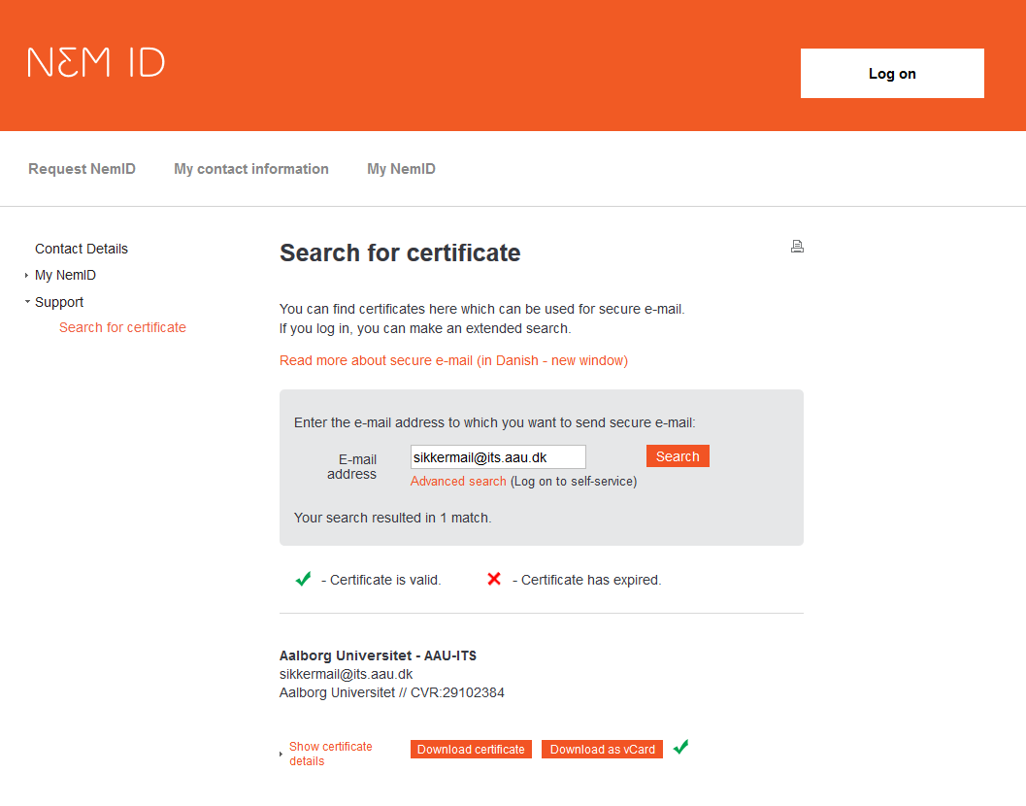
Når certifikatet er installeret, skal du sende en krypteret e-mail til vores sikker mail-postkasse, eksempelvis sikkermail@its.aau.dk, og vi er nu klar til at kommunikere sikkert.

Background
Aalborg University has decided that all external communication containing data that can be related to natural persons must be encrypted before it is sent.
All encrypted secure e-mail communication is based on unique certificates. Both sender and recipient must be in possession of a certificate before they can decrypt each other’s e-mails.
How?
If Aalborg University is to communicate securely with you, you must acquire a PKCS12-compatible certificate.
The certificate is to be placed in your e-mail programme. Unfortunately, AAU is unable to guide you in this matter, as it wholly depends on your choice of e-mail programme and supplier.
Once this is in order, you must fetch Aalborg University’s certificate here: https://service.nemid.nu/dk-en/support/search_for_certificate/
- select the name of the secure e-mail address that you are going to use (See example below):
In the above example sikkermail@its.aau.dk is only used as an example.
Once the certificate is installed, you are ready to communicate with your AAU contact via encrypted e-mails. You’re now good to go!

